|  |  |
| --- | --- |
| **VISVESVARAYATECHNOLOGICALUNIVERSITY**  **“JnanaSangama”, Belgaum -590014, Karnataka.**    **LAB REPORT**  **On**    **DATA STRUCTURES (23CS3PCDST)**      **Submitted by**  **Harsha B (1BM23CS107)**    **in partial fulfillment for the award of the degree of**  **BACHELOR OF ENGINEERING**  **in**  **COMPUTER SCIENCE AND ENGINEERING**                            **B.M.S. COLLEGE OF ENGINEERING**  **(Autonomous Institution under VTU) BENGALURU-**  **560019**  **September 2024-January 2025** | 1 |

**B. M. S. College of Engineering, Bull Temple Road, Bangalore 560019**

**(Affiliated To Visvesvaraya Technological University, Belgaum) Department of Computer Science and Engineering**



This is to certify that the Lab work entitled **“DATA STRUCTURES”** carried out by Harsha B (1BM23CS107) , who is bonafide student of **B. M. S. College of Engineering**. It is in partial fulfillment for the award of **Bachelor of Engineering in Computer Science and Engineering** of the Visvesvaraya Technological University, Belgaum during the year 2024- 25. The Lab report has been approved as it satisfies the academic requirements in respect of Data structures Lab - **(23CS3PCDST)** work prescribed for the said degree.

|  |  |
| --- | --- |
| **Dr. Selva kumar S** | **Dr. Kavitha Sooda** |
| Associate Professor | Professor and Head |
| Department of CSE | Department of CSE |
| BMSCE, Bengaluru | BMSCE, Bengaluru |

**Index Sheet**

|  |  |  |
| --- | --- | --- |
| **Sl.**  **No.** | **Experiment Title** | **Page No.** |
| 1 | 1a. stack using an array | 3 - 5 |
| 2 | 2a. infix to postfix conversion    2b. Leetcode problem | 5 - 8 |
| 3 | 3a. Queue using an array    3b. Circular queue using an array | 9 - 13 |
| 4 | 4a.Singly linked list (Insertion)    4b. Leetcode problem | 13 - 18 |
| 5 | 5a. Singly Linked List (Deletion)    5b. Leetcode problem | 18 - 23 |
| 6 | 6a. Singly Linked List (sorting,reversing , concatination)    6b. Stack and Queue using singly linked list | 23 - 31 |
| 7 | 7a. Doubly linked list (Insertion and Deletion)    7b.Leetcode problem | 32 - 37 |
| 8 | 8a. Binary search tree (BST)    8b. Leetcode problem | 37 - 40 |
| 9 | 9a. Write a program to traverse a graph using BFS method.  9b. Write a program to check whether given graph is connected or not using DFS method. | 41-44 |
| 10 | Given a File of N employee records with a set K of Keys(4-digit) which uniquely determine the records in file F. Assume that file F is maintained in memory by a Hash Table (HT) of m memory locations with L as the set of memory addresses (2-digit) of locations in HT. Let the keys in K and addresses in L are integers. Design and develop a Program in C that uses Hash function H: K -> L as H(K)=K mod m (remainder method), and implement hashing technique to map a given key K to the address space L. Resolve the collision (if any) using linear probing. | 44-46 |

**Course outcomes:**

|  |  |
| --- | --- |
| CO1 | Apply the concept of linear and nonlinear data structures. |
| CO2 | Analyze data structure operations for a given problem |
| CO3 | Design and develop solutions using the operations of linear and nonlinear data structure for a given specification. |
| CO4 | Conduct practical experiments for demonstrating the operations of different data structures. |

**Lab program 1:**

**Write a program to simulate the working of stack using an array with the following: a)**

**Push**

1. **Pop**
2. **Display**

**The program should print appropriate messages for stack overflow, stack underflow.**

**#include<stdio.h>**

**#include<stdlib.h> #define max 4 int stack[max];**

**int top=-1;**

**void push(int x){**

**if(top==max-1){ printf("Stack is full\n");**

**}**

**else{**

**top++;**

**stack[top]=x;**

**}**

**void pop(){ if(top==-1){ printf("Stack is empty\n");**

**}**

**else{ top--;**

**}**

**}**

**void peek(){ if(top!=-1){ printf("%d",stack[top]);**

**}**

**}**

**void display(){ if(top==-1){ printf("Stack is empty\n");**

**}**

**else{ for(int i=top;i>=0;i--){ printf("%d\n",stack[i]);**

**}**

**}**

**}**

**void main(){ int choice,data; while(1){ printf("\n1.Push \n2.Pop \n3.Peek \n4.Display \n5.Exit\n");**

**printf("Enter your choice: "); scanf("%d",&choice); switch(choice){**

**case 1:printf("Enter a data to insert: "); scanf("%d",&data); push(data); break;**

**case 2:pop(); break;**

**case 3:peek(); break;**

**case 4:display(); break;**

**case 5:exit(0);**

**break;**

**default:printf("Invalid choice.");**

**}**

**}**

**}**

**Output:**

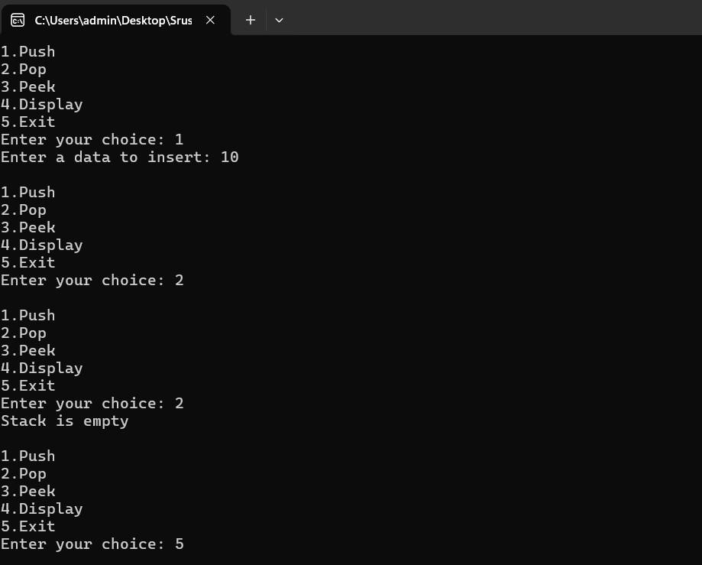

**Lab program 2a:**

**WAP to convert a given valid parenthesized infix arithmetic expression to postfix expression. The expression consists of single character operands and the binary operators + (plus), - (minus), * (multiply) and / (divide)**

**#include<stdio.h>**

**#include<string.h> #define max 30 char s1[max];//postfix char s2[max];//infix int t1=-1,t2=-1;**

**int precedence(char x){ if(x=='*' || x=='/'){ return 2;**

**}**

**else if(x=='+' || x=='-'){ return 1;**

**}**

**else if(x=='^'){ return 3;**

**}**

**return 0;**

**}**

**void push1(char x){**

**if(t1==max-1){ printf("Stack is full\n"); return;**

**}**

**else{ t1++; s1[t1]=x;**

**}**

**}**

**void push2(char x){**

**if(t2==max-1){ printf("Stack is full\n"); return;**

**}**

**else{ t2++;**

**s2[t2]=x;**

**}**

**}**

|  |  |
| --- | --- |
| **char pop1(){ if(t1==-1){ printf("Stack is empty\n");**  **return '\0';**  **}**  **return s1[t1--];**  **}**    **char pop2(){ if(t2==-1){ printf("Stack is empty\n"); return '\0';**  **}**  **return s2[t2--];**  **}**    **char peek2(){ if(t2!=-1){**    **return s2[t2];**  **}**  **return '\0';**  **}**    **void main(){ char str[max];**  **printf("Enetr a expression: "); scanf("%s",str);**    **for(int i=0;i<strlen(str);i++){ char ch=str[i];**    **if(ch=='('){ push2(ch);**  **}**  **else if(ch==')'){ while(peek2()!='('){ push1(pop2());**  **}**  **pop2();**  **}**  **else if(ch=='+'|| ch=='-'|| ch=='*' || ch=='/' || ch=='^'){ while(t2>-1 && precedence(peek2())>=precedence(ch)){ push1(pop2());**  **}**  **push2(ch);**  **}** | 7 |

**else if(ch>='a' && ch<='z'){ push1(ch);**

**}**

**}**

**while(t2>-1){**

**push1(pop2());**

**}**

**for(int i=0;i<=t1;i++){ printf("%c",s1[i]);**

**}**

**Output:**

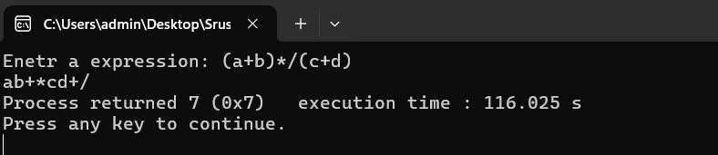

**Lab program 2b:**

**Demonstration of account creation on LeetCode platform Program - Leetcode platform. void moveZeroes(int* nums, int numsSize) { int lastNonZeroFoundAt = 0; for (int current = 0; current < numsSize; current++) { if (nums[current] != 0) { nums[lastNonZeroFoundAt++] = nums[current];**

**}**

**}**

**for (int i = lastNonZeroFoundAt; i < numsSize; i++) { nums[i] = 0;**

**}**

**}**

**Output:**

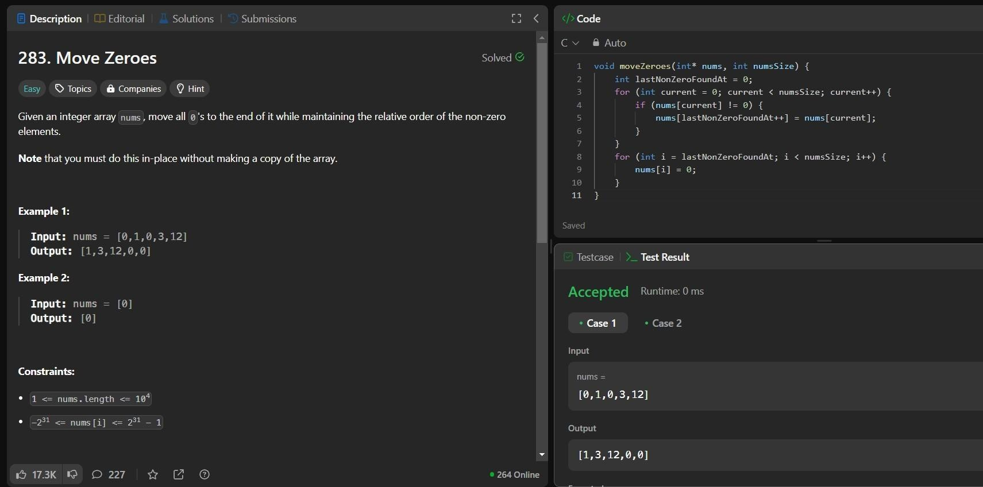

**Lab program 3a:**

**WAP to simulate the working of a queue of integers using an array. Provide the following operations: Insert, Delete, Display The program should print appropriate messages for queue empty and queue overflow conditions.**

**#include<stdio.h>**

**#include<stdlib.h> #define n 4 int queue[n]; int front=-1,rear=-1;**

**void enqueue(int x){ if(rear==n-1){ printf("Queue is full\n");**

**}**

**else if(rear==-1 && front==-1){ rear=front=0;**

**queue[rear]=x;**

**} else{ rear++;**

**queue[rear]=x;**

**}**

**}**

**void dequeue(){ if(rear==-1 && front==-1){ printf("Queue is empty\n");**

**}**

**else if(front==rear){ front=rear=-1;**

**}**

**else{ front++;**

**}**

**}**

**void display(){ if(rear==-1 && front==-1){ printf("Queue is empty\n");**

**} else{ for(int i=front;i<=rear;i++){ printf("%d\n",queue[i]);**

**}**

**} }**

**void main(){ int choice,data; while(1){ printf("\n1.Enqueue \n2.Dequeue \n3.Display \n4.Exit\n"); printf("Enter your choice: "); scanf("%d",&choice); switch(choice){ case 1:printf("Enter a data to insert: "); scanf("%d",&data); enqueue(data); break;**

**case 2:dequeue(); break;**

**case 3:display(); break;**

**case 4:exit(0); break;**

**default:printf("Invalid choice.");**

**}**

**}**

**}**

**Output:**

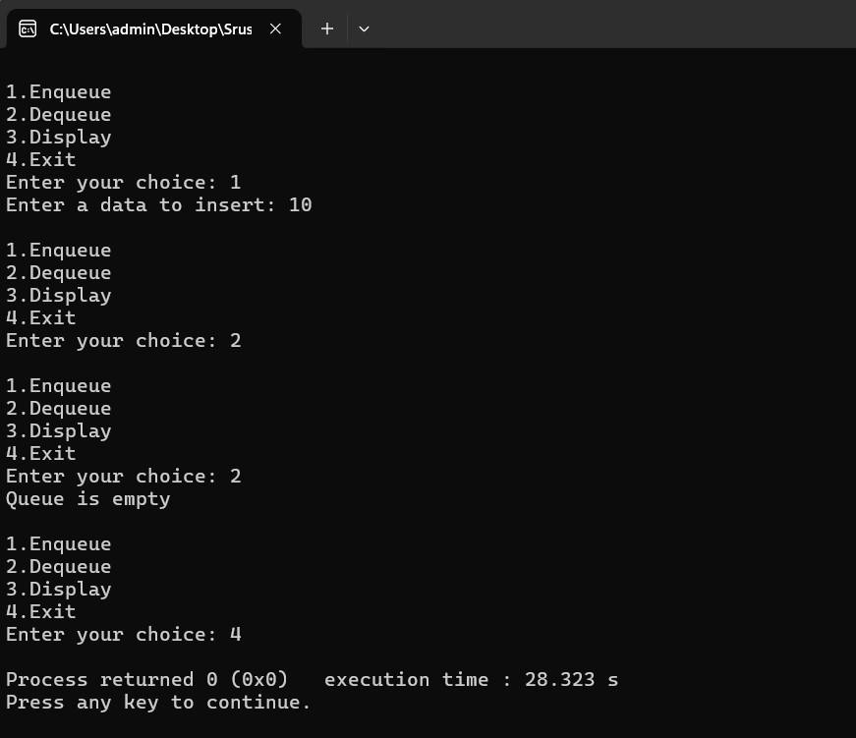

**Lab program 3b:**

**WAP to simulate the working of a circular queue of integers using an array. Provide the following operations: Insert, Delete & Display The program should print appropriate messages for queue empty and queue overflow conditions**

10

|  |  |
| --- | --- |
| **#include<stdio.h>**  **#include<stdlib.h> # define n 4 int q[n];**  **int rear=-1, front=-1;**    **void enqueue(int x){ if(front==(rear+1)%n){ printf("Queue is full\n");**  **}**  **else if(front==-1 && rear==-1){ front=rear=0;**  **q[rear]=x;**  **}**  **else{ rear=(rear+1)%n; q[rear]=x;**  **}**  **}**    **void dequeue(){ if(front==-1 && rear==-1){ printf("Queue is Empty\n");**  **}**  **else if(rear==front){ front=rear=-1;**  **}**  **else { front=(front+1)%n;**  **}**  **}**    **void display(){ if(front==-1 && rear==-1){ printf("Queue is empty\n");**  **}**  **else{ for(int i=front;i!=rear;i++){ printf("%d ",q[i]);**  **}**  **printf("%d",q[rear]);**  **}**  **}**    **void main(){ int choice,data; while(1){ printf("\n1.Enqueue \n2.Dequeue \n3.Display \n4.Exit\n");** | 11 |

1

2

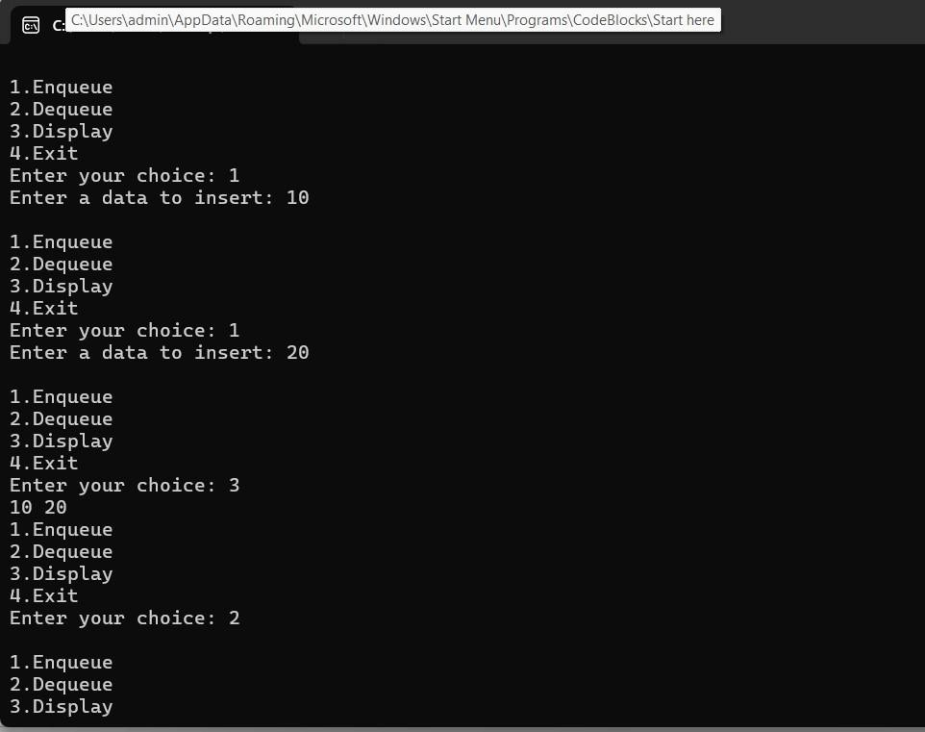

**printf("Enter**

**your**

**choice:**

**");**

**scanf("%d",&choice);**

**switch(choice){**

**case**

**1:**

**printf("Enter**

**a**

**data**

**to**

**insert:**

**");**

**scanf("%d",&data);**

**enqueue(data);**

**break;**

**case**

**2:**

**dequeue();**

**break;**

**case**

**3:**

**display();**

**break;**

**case**

**exit(0);**

**4:**

**break;**

**default:printf("Invalid**

**choice.");**

**}**

**}**

**}**

**Output:**

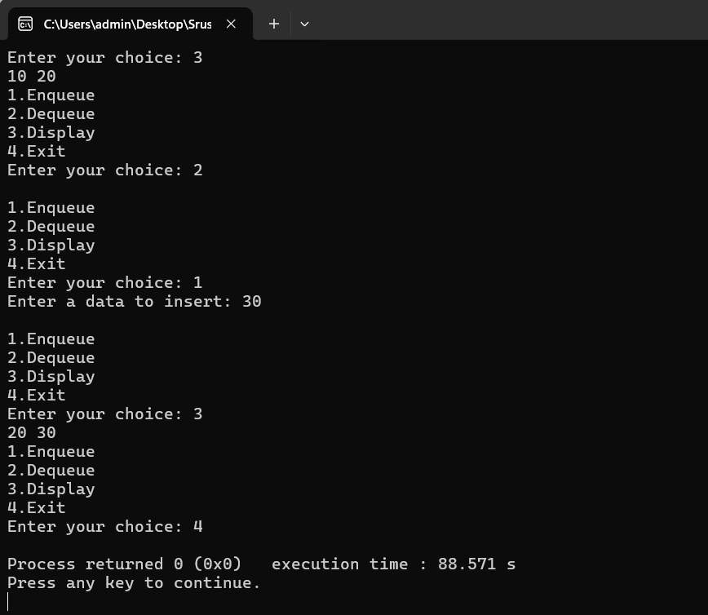

**Lab program 4a:**

**WAP to Implement Singly Linked List with following operations a) Createalinkedlist.**

**b) Insertion of a node at first position, at any position and at end of list.**

**Display the contents of the linked list.**

**#include<stdio.h>**

**#include<stdlib.h>**

**struct Node{ int data; struct Node *next;**

**};**

**struct Node *CreateNode(int data){ struct Node *newnode=(struct Node*)malloc(sizeof(struct Node)); newnode->data=data; newnode->next=NULL;**

**return newnode;**

**}**

**void insertAtFirst(struct Node* *head,int data){**

**struct Node* newnode=CreateNode(data);**

|  |  |
| --- | --- |
| **newnode->next=*head;**  **\*head=newnode;**  **}**    **void insertAtEnd(struct Node* *head,int data){ struct Node* newnode=CreateNode(data); if(*head==NULL){ *head=newnode;**  **return;**  **}**  **struct Node *temp=*head; while(temp->next!=NULL){ temp=temp->next;**  **}**  **temp->next=newnode;**  **}**    **void insertAtPos(struct Node* *head,int data,int pos){ struct Node* newnode=CreateNode(data); if(pos==1){ newnode->next=*head; *head=newnode;**  **return;**  **}**  **struct Node *temp=*head;**  **for(int i=1;i<pos-1 && temp!=NULL;i++){ temp=temp->next;**  **}**  **if(temp==NULL){**  **printf("Position out of range.\n");**  **free(newnode);**  **return;**  **}**  **newnode->next=temp->next;**  **temp->next=newnode;**  **}**    **void display(struct Node *head){ struct Node *temp=head; while(temp!=NULL){ printf("%d ",temp->data); temp=temp->next;**  **}**  **}**    **void main(){ struct Node *head=NULL; int data, choice,pos; while(1){** | 14 |

**printf("\n1.Insert At Front \n2.Insert At End \n3.Insert At Position \n4.Display \n5.Exit"); printf("\nEnter your choice: "); scanf("%d",&choice); switch(choice){ case 1:printf("Enter a data to be insert: "); scanf("%d",&data); insertAtFirst(&head,data); break;**

**case 2:printf("Enter a data to be insert: "); scanf("%d",&data); insertAtEnd(&head,data); break;**

**case 3:printf("Enter a position: "); scanf("%d",&pos);**

**printf("Enter a data to be insert: ");**

**scanf("%d",&data); insertAtPos(&head,data,pos); break;**

**case 4:display(head); break;**

**case 5:exit(0); break;**

**default:printf("Invalid choice.");**

**}**

**}**

**}**

**Output:**

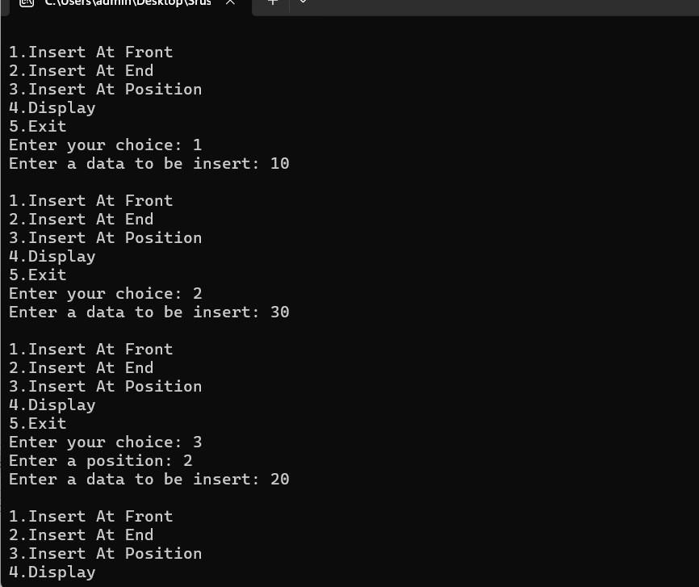

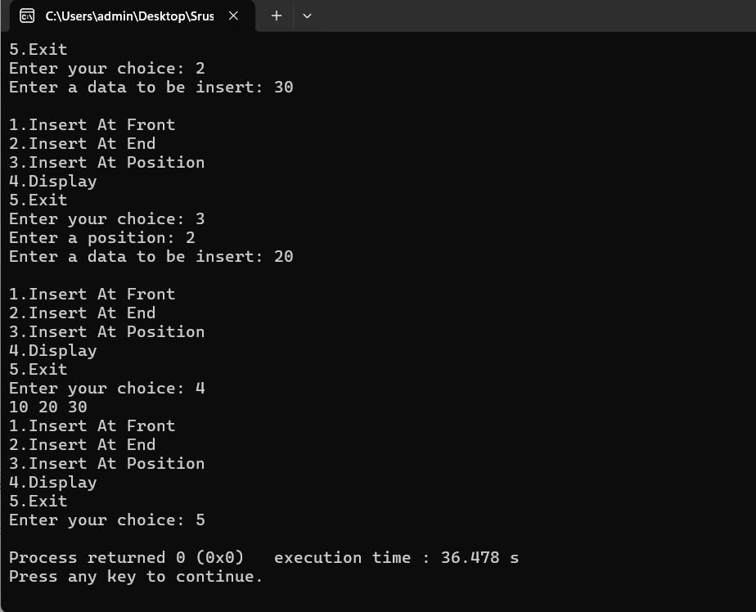

**Lab program 4b:**

**Program - Leetcode platform**

**int firstUniqChar(char* s) { int freq[26] = {0}; int length = strlen(s); for (int i = 0; i < length; i++) { freq[s[i] - 'a']++;**

**}**

**for (int i = 0; i < length; i++) { if (freq[s[i] - 'a'] == 1) { return i;**

**}**

**}**

**return -1;**

**}**

**Output:**

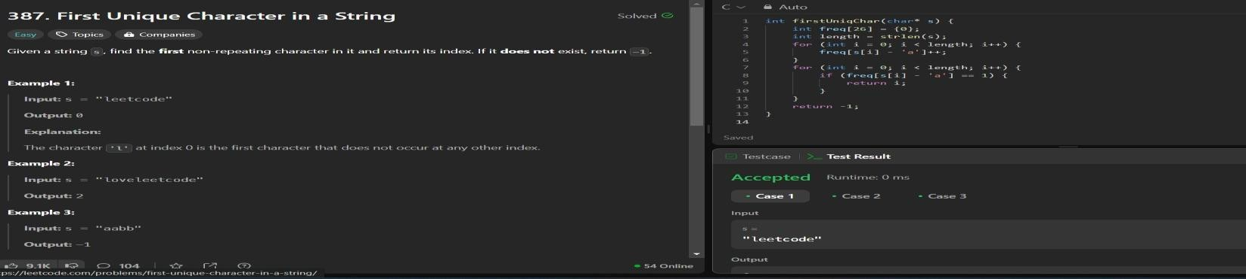

**Program - Leetcode platform**

**void processString(char* str, char* result) { int index = 0;**

**for (int i = 0; str[i] != '\0'; i++) { if (str[i] != '#') { result[index++] = str[i];**

**} else if (index > 0) { index--;**

**}**

**}**

**result[index] = '\0';**

**}**

**bool backspaceCompare(char* s, char* t) { char processedS[201]; char processedT[201]; processString(s, processedS); processString(t, processedT); return strcmp(processedS, processedT) == 0;**

**}**

**Output:**

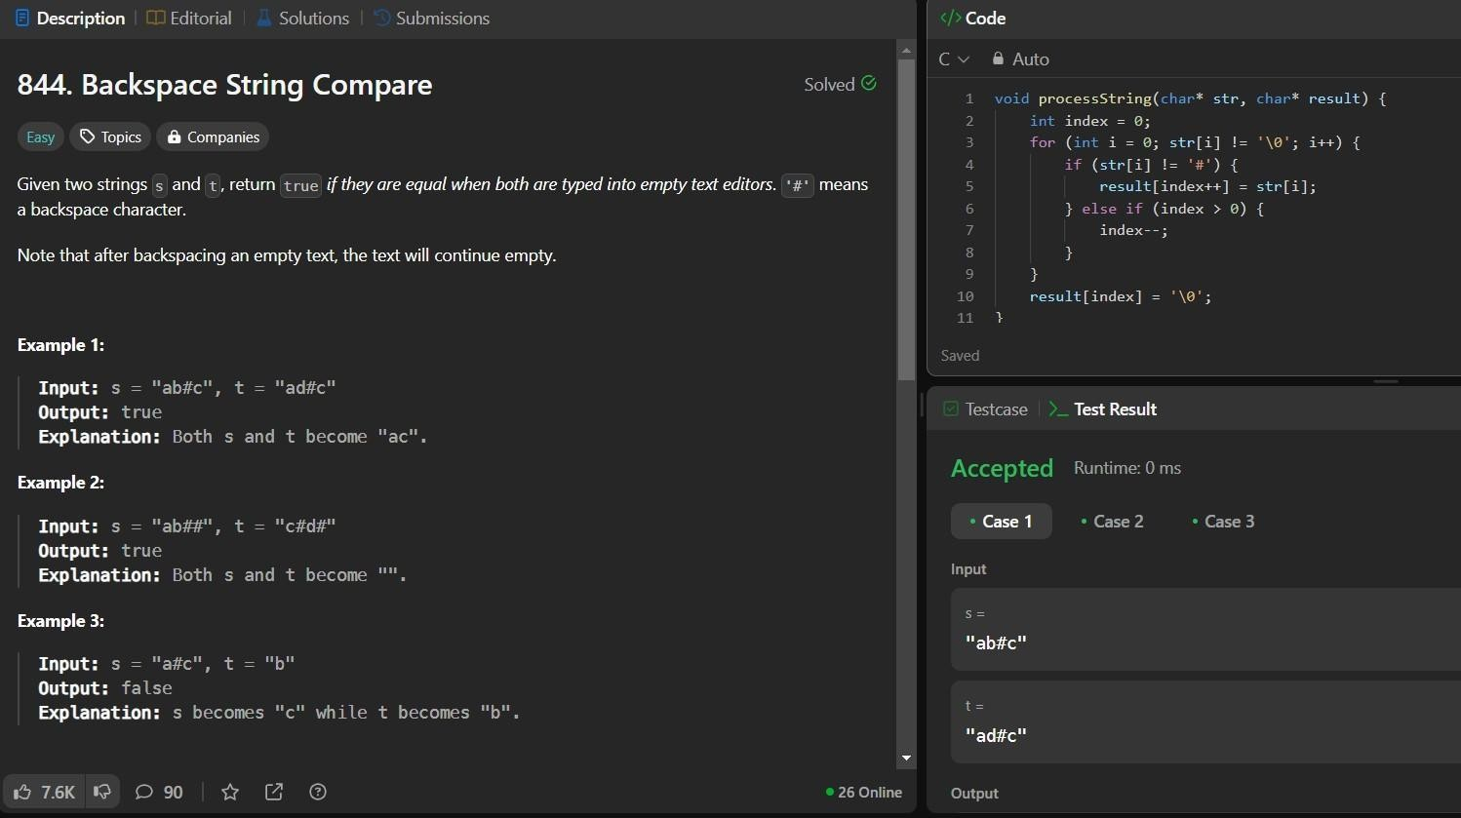

**Program - Leetcode platform**

**char* removeOneOccurrence(char* number, int index) { int len = strlen(number);**

**char* result = (char*)malloc(len * sizeof(char));**

**int k = 0; for (int i = 0; i < len; i++) { if (i != index) {**

**result[k++] = number[i];**

**}**

**}**

**result[k] = '\0'; return result;**

**}**

**char* removeDigit(char* number, char digit) { char* maxString = NULL;**

**for (int i = 0; number[i] != '\0'; i++) { if (number[i] == digit) {**

**char* newString = removeOneOccurrence(number, i); if (maxString == NULL || strcmp(newString, maxString) > 0) { if (maxString != NULL) { free(maxString);**

**}**

**maxString = newString;**

**}**

**else { free(newString);**

**}**

**}**

**}**

**return maxString;**

**}**

**Output:**

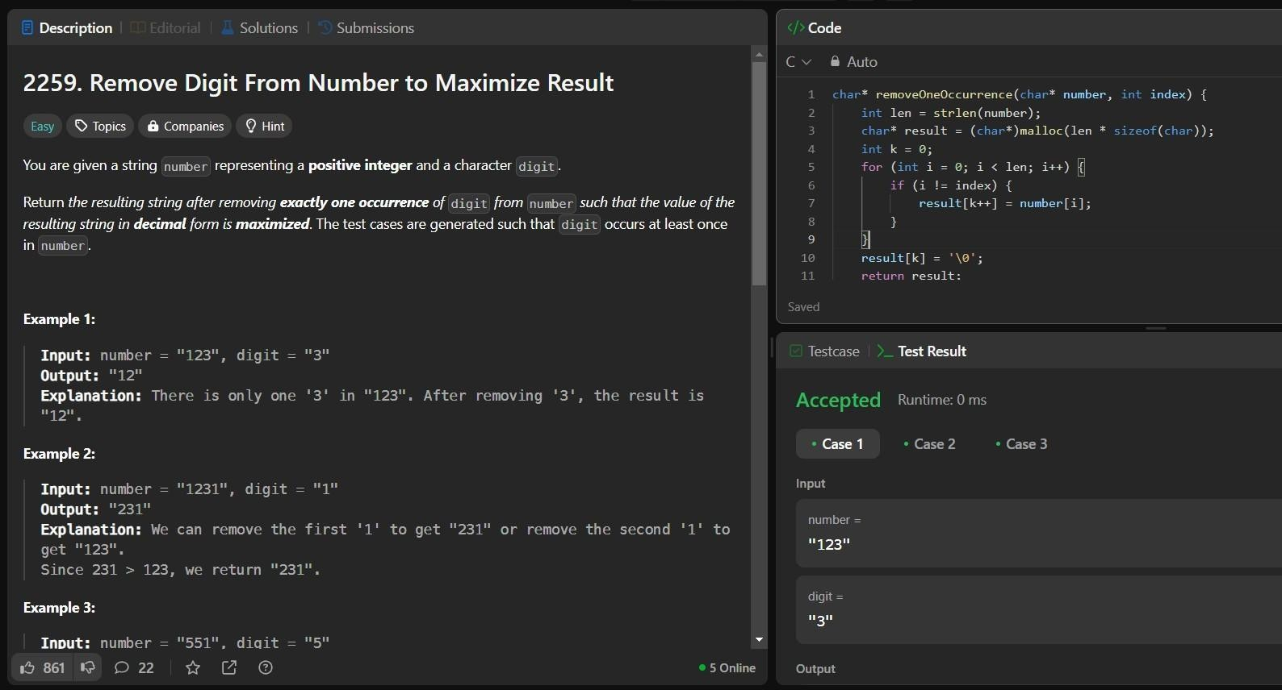

**Lab program 5a:**

**WAP to Implement Singly Linked List with following operations a) Create a linked list.**

1. **Deletion of first element, specified element and last element in the list.**
2. **Display the contents of the linked list.**

|  |  |
| --- | --- |
| **#include<stdio.h>**  **#include<stdlib.h>**    **struct Node{ int data;**  **struct Node *next;**  **};**    **struct Node *CreateNode(int data){ struct Node *newnode=(struct Node*)malloc(sizeof(struct Node)); newnode->data=data; newnode->next=NULL;**  **return newnode;**  **}**    **void insertAtEnd(struct Node* *head,int data){ struct Node* newnode=CreateNode(data); if(*head==NULL){ *head=newnode;**  **return;**  **}**  **struct Node *temp=*head; while(temp->next!=NULL){ temp=temp->next;**  **}**  **temp->next=newnode;**  **}**    **void deleteAtFront(struct Node* *head){ if(*head==NULL){ printf("List is Empty\n");**  **}**  **struct Node *temp1=*head; struct Node *temp2=temp1->next;**  **\*head=temp2;**  **free(temp1);**  **}**    **void deleteAtEnd(struct Node* *head){ if(*head==NULL){ printf("List is empty\n");**  **}**    **struct Node *temp1=*head; struct Node *temp2=NULL;**    **if(temp1->next==NULL){ free(temp1);** | 19 |

**\*head=NULL;**

**}**

**while(temp1->next!=NULL){**

**temp2=temp1;**

**temp1=temp1->next;**

**}**

**temp2->next=NULL;**

**free(temp1);**

**}**

**void deleteAtPos(struct Node* *head,int pos){**

**if(*head==NULL){ printf("List is empty\n");**

**}**

**struct Node *temp1=*head; struct Node *temp2=NULL;**

**if(pos==1){**

**\*head=temp1->next;**

**free(temp1);**

**}**

**for(int i=1;i<pos-1 && temp1!=NULL;i++){**

**temp1=temp1->next;**

**}**

**if(temp1==NULL || temp1->next==NULL){ printf("Position out of range\n");**

**}**

**temp2=temp1->next; temp1->next=temp2->next;**

**free(temp2);**

**}**

**void display(struct Node *head){**

**struct Node *temp=head; while(temp!=NULL){ printf("%d ",temp->data);**

**temp=temp->next;**

**}**

**}**

**void main(){**

**struct Node *head=NULL; int data, choice,pos; while(1){ printf("\n1.Insertion \n2.Delete At Front \n3.Delete At End \n4.Delete At Position \n5.Display**

**\n6.Exit"); printf("\nEnter your choice: "); scanf("%d",&choice); switch(choice){**

**case 1:printf("Enter a data to be insert: ");**

**scanf("%d",&data); insertAtEnd(&head,data);**

**break;**

**case 2:deleteAtFront(&head); break;**

**case 3:deleteAtEnd(&head);**

**break;**

**case 4:printf("Enter a position: ");**

**scanf("%d",&pos); deleteAtPos(&head,pos); break;**

**case 5:display(head);**

**break;**

**case 6:exit(0);**

**break;**

**default:printf("Invalid choice.");**

**}**

**}**

**}**

**Output:**

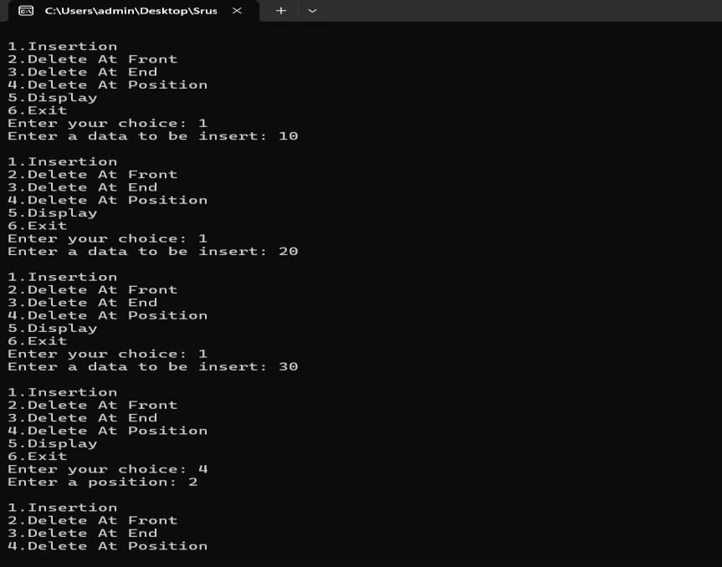

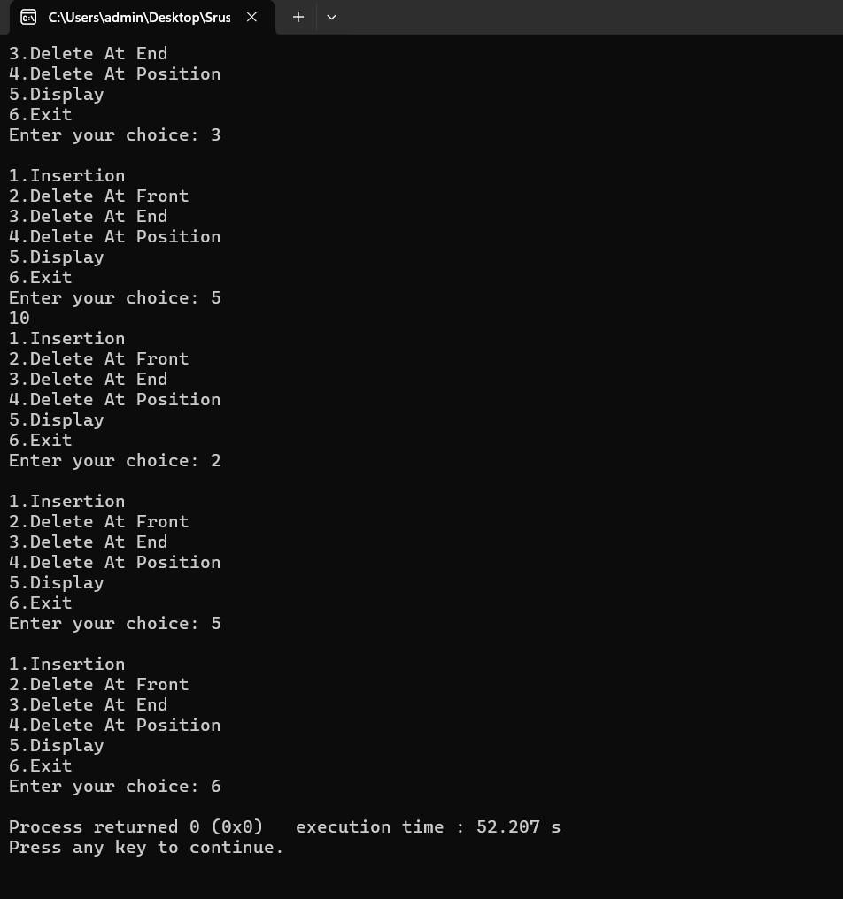

**Lab program 5b:**

**Program - Leetcode platform struct ListNode* deleteDuplicates(struct ListNode* head) { struct ListNode* current = head;**

**while (current != NULL && current->next != NULL) { if (current->val == current->next->val) { struct ListNode* temp = current->next; current->next = current->next->next; free(temp);**

**} else {**

**current = current->next;**

**}**

**}**

**return head;**

**}**

**struct ListNode* createNode(int val) { struct ListNode* newNode = (struct ListNode*)malloc(sizeof(struct ListNode)); newNode->val = val; newNode->next = NULL;**

**return newNode;**

**}**

**void printList(struct ListNode* head) { struct ListNode* current = head; while (current != NULL) { printf("%d -> ", current->val); current = current->next;**

**}**

**printf("NULL\n");**

**}**

**Output:**

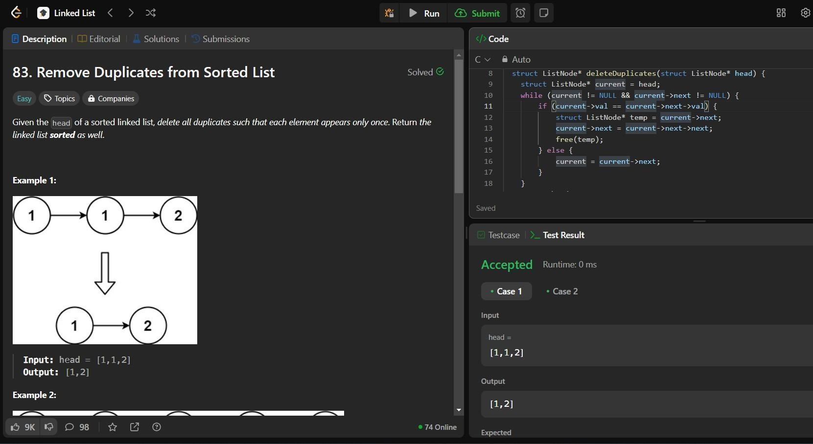

**Lab program 6a:**

**WAP to Implement Single Link List with following operations: Sort the linked list, Reverse the linked list, Concatenation of two linked lists.**

**#include<stdio.h>**

**#include<stdlib.h>**

**#include<stdbool.h>**

**struct Node{ int data; struct Node *next;**

**};**

**struct Node *createNode(int data){**

**struct Node *newnode=(struct Node *)malloc(sizeof(struct Node)); newnode->data=data; newnode->next=NULL; return newnode;**

**}**

**void insertEnd(struct Node* *head,int data){ struct Node *newnode=createNode(data); if(*head==NULL){**

**\*head=newnode;**

|  |  |
| --- | --- |
| **}else{**  **struct Node *temp=*head; while(temp->next!=NULL){ temp=temp->next;**  **}**  **temp->next=newnode;**  **}**  **}**    **void sort(struct Node* *head){ if(*head==NULL || (*head)->next==NULL){ return;**  **}**  **struct Node *i=*head; while(i!=NULL){ struct Node *j=i->next; while(j!=NULL){ if(i->data > j->data){ int temp=i->data; i->data=j->data;**  **j->data=temp;**  **}**  **j=j->next;**  **}**  **i=i->next;**  **}**  **}**    **void reverse(struct Node* *head){ struct Node *prev=NULL; struct Node *curr=*head; struct Node *nextn=NULL;**    **while(curr!=NULL){ nextn=curr->next; curr->next=prev; prev=curr; curr=nextn;**  **}**  **\*head=prev;**  **}**    **void concate(struct Node* *head1,struct Node* *head2){ if(*head1==NULL){**  **\*head1=*head2;**  **}** | 24 |

|  |  |
| --- | --- |
| **struct Node *temp=*head1; while(temp->next!=NULL){ temp=temp->next;**  **}**  **temp->next=*head2;**  **\*head2=NULL;**  **}**  **void display(struct Node* head){ struct Node *temp=head; while(temp!=NULL){ printf("%d ",temp->data); temp=temp->next;**  **}**  **printf("\n");**  **}**    **void main()**  **{**  **struct Node *list1=NULL; struct Node *list2=NULL; int data,choice;**    **while(true){ printf("1.Insert into list1.\n"); printf("2.Insert into list 2.\n"); printf("3.Sort list 1\n"); printf("4.Reverse list 1\n"); printf("5.Concatination\n"); printf("6.Display\n"); printf("7.Exit\n");**    **printf("Enter your choice: "); scanf("%d",&choice); switch(choice){ case 1:printf("enter data to insert into list1: \n"); scanf("%d",&data); insertEnd(&list1,data); break;**  **case 2:printf("enter data to insert into list2: \n"); scanf("%d",&data); insertEnd(&list2,data); break;**  **case 3:sort(&list1); printf("Done\n"); break;**  **case 4:reverse(&list1);** | 25 |

2

6

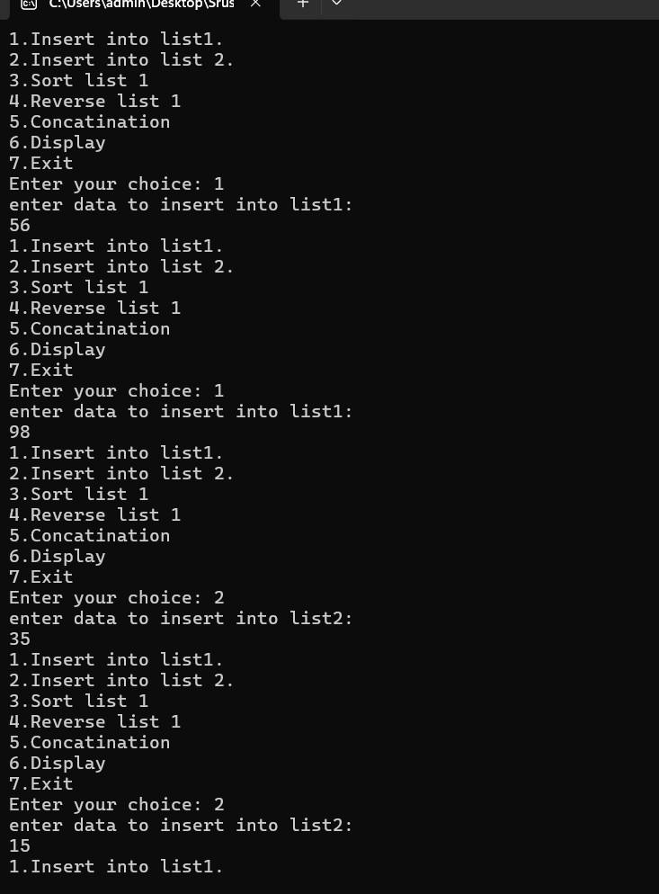

**printf("Done**

**\**

**n");**

**break;**

**case 5:concate(&list1,&list2);**

**printf("Done**

**\**

**n");**

**break;**

**case**

**6:**

**printf("List1:");**

**display(list1);**

**printf("List2:");**

**display(list2);**

**break;**

**case**

**7:**

**exit(0);**

**break;**

**default:printf("Invalid**

**Choice**

....

**\**

**n");**

**break;**

**}**

**}**

**}**

**Output:**

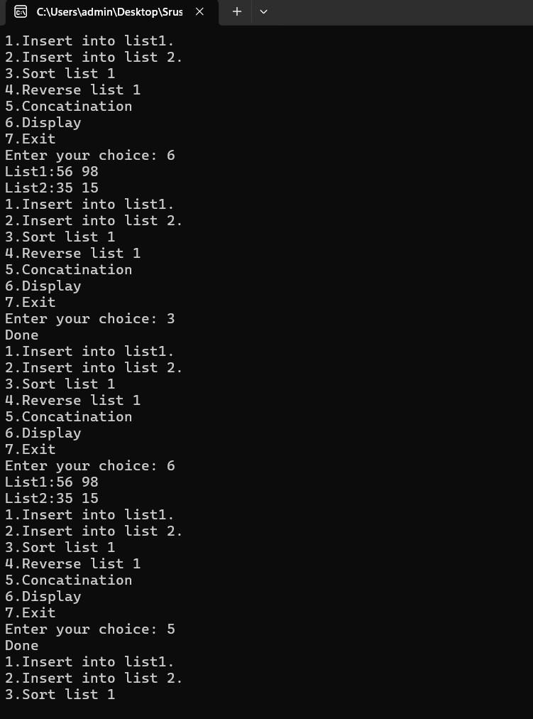

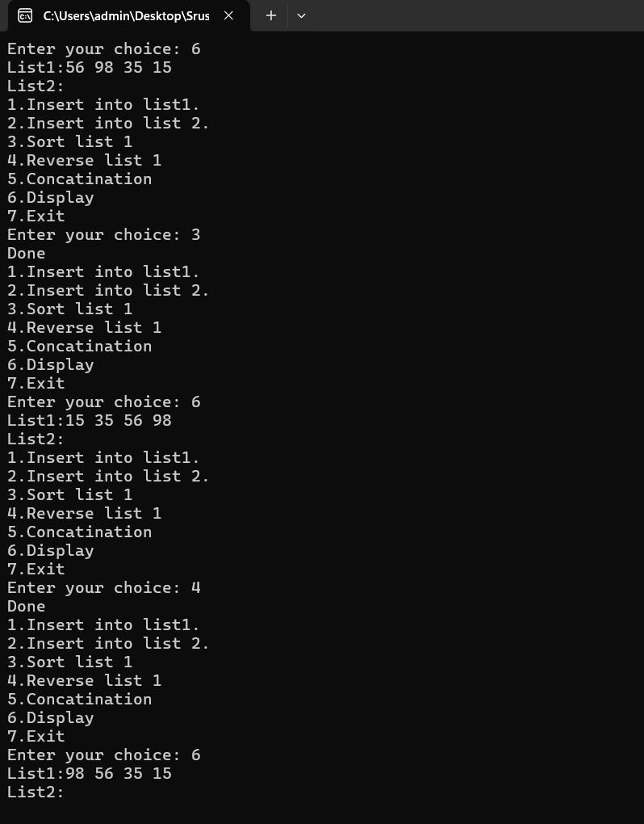

|  |  |
| --- | --- |
| **Lab program 6b:**  **WAP to Implement Single Link List to simulate Stack Operation.**  **#include<stdio.h>**  **#include<stdlib.h>**  **#include<stdbool.h>**    **struct Node{ int data;**  **struct Node *next;**  **};**    **void push(int x,struct Node* *top){ struct Node newnode=(struct Node)malloc(sizeof(struct Node)); newnode->data=x; newnode->next=*top;**  **\*top=newnode;**  **}**    **void pop(struct Node* *top){ if(*top==NULL){ printf("Empty\n");**  **}**  **struct Node *temp=*top; *top=(*top)->next; free(temp);**  **}**  **void peek(struct Node* top) { if (top == NULL) { printf("Empty\n");**  **} else { printf("%d \n", top->data);**  **}**  **}**    **void display(struct Node* top) { struct Node* temp = top; while (temp != NULL) { printf("%d ", temp->data); temp = temp->next;**  **}**  **printf("\n");**  **}**    **void main(){ int data,choice; struct Node *top=NULL;** | 28 |

**while(true){**

**printf("1.Push\n"); printf("2.Pop\n"); printf("3.Peek\n"); printf("4.Display\n"); printf("5.Exit\n");**

**printf("Enter your choice: "); scanf("%d",&choice);**

**switch(choice){**

**case 1:printf("Enter data:");**

**scanf("%d",&data); push(data,&top); break;**

**case 2:pop(&top); break;**

**case 3:peek(top); break;**

**case 4:display(top);**

**break;**

**case 5:exit(0);**

**break;**

**default:printf("Invalid Choice\n");**

**break;**

**}**

**}**

**}**

**Output:**

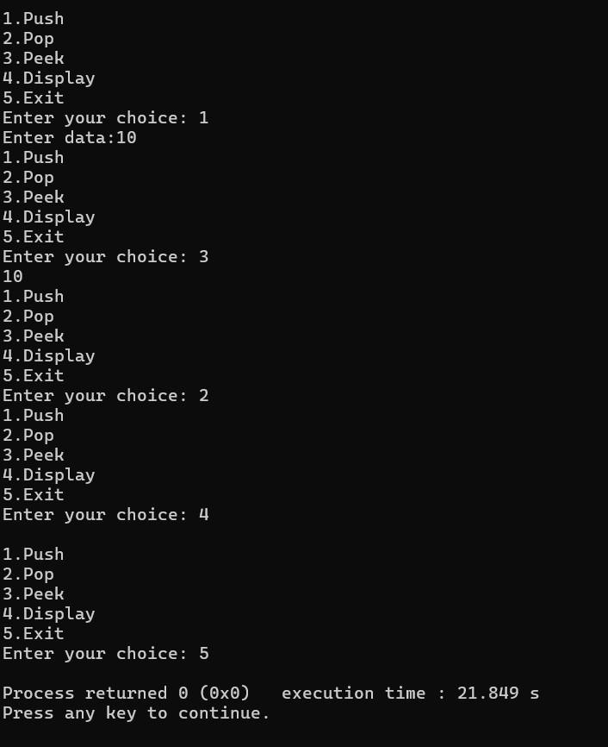

|  |  |
| --- | --- |
| **WAP to Implement Single Link List to simulate Queue Operation.**  **#include<stdio.h>**  **#include<stdlib.h>**    **struct Node{ int data;**  **struct Node *next;**  **};**    **void enqueue(struct Node* *front,struct Node* *rear,int data){ struct Node *newnode=(struct Node*)malloc(sizeof(struct Node)); newnode->data=data; newnode->next=NULL;**    **if(*front==NULL && *rear==NULL){ *front=*rear=newnode;**  **}**  **else{**  **(*rear)->next=newnode;**  **\*rear=newnode;**  **}**  **}**    **void dequeue(struct Node* *front,struct Node* *rear){ if(*front==NULL && *rear==NULL){ printf("Queue is empty\n");**  **}**  **else if(*front==*rear){ *front=*rear=NULL;**  **}**  **else{**  **\*front=(*front)->next;**  **}**  **}**    **void display(struct Node* front){ struct Node *temp=front; if(front==NULL){ printf("Queue is empty\n");**  **}**  **while(temp!=NULL){ printf("%d ",temp->data); temp=temp->next;**  **}**  **printf("\n");**  **}** | 30 |

**void main(){**

**int data,choice; struct Node *front=NULL; struct Node *rear=NULL;**

**while(1){**

**printf("1.Enqueue\n"); printf("2.Dequeue\n"); printf("3.Display\n"); printf("4.Exit\n");**

**printf("Enter your choice:"); scanf("%d",&choice);**

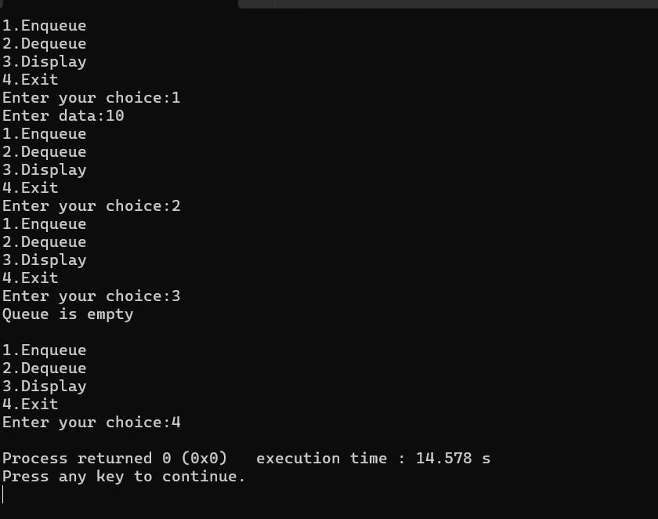**switch(choice){**

**case 1:printf("Enter data:"); scanf("%d",&data); enqueue(&front,&rear,data); break;**

**case 2:dequeue(&front,&rear);**

**break;**

**case 3:display(front);**

**break;**

**case 4:exit(0);**

**break;**

**default:printf("Invalid choice\n");**

**}**

**}**

**}**

**Output:**

|  |  |
| --- | --- |
| **Lab program 7a:**  **WAP to Implement doubly link list with primitive operations a) Create a doubly linked list.**   1. **Insert a new node to the left of the node.** 2. **Delete the node based on a specific value.** 3. **Display the contents of the list.**   **#include <stdio.h> #include <stdlib.h> struct Node { int data; struct Node *prev;**  **struct Node *next;**  **};**  **struct Node* createNode(int data) { struct Node *newNode = (struct Node *)malloc(sizeof(struct Node)); if (!newNode) { printf("Memory allocation failed\n"); exit(1);**  **}**  **newNode->data = data; newNode->prev = NULL; newNode->next = NULL; return newNode;**  **}**  **void insertLeft(struct Node **head, struct Node *node, int data) { struct Node *newNode = createNode(data); newNode->next = node; newNode->prev = node->prev; if (node->prev != NULL) { node->prev->next = newNode;**  **} else {**  **\*head = newNode;**  **}**  **node->prev = newNode;**  **}**  **void deleteNode(struct Node **head, int value) { struct Node *temp = *head;**  **while (temp != NULL && temp->data != value) { temp = temp->next;**  **}**  **if (temp == NULL) { printf("Node with value %d not found\n", value); return;**  **}** | 32 |

|  |  |
| --- | --- |
| **if (temp->prev != NULL) { temp->prev->next = temp->next;**  **} else {**  **\*head = temp->next;**  **}**  **if (temp->next != NULL) { temp->next->prev = temp->prev;**  **}**  **free(temp);**  **}**  **void displayList(struct Node *head) { struct Node *temp = head; while (temp != NULL) { printf("%d ", temp->data);**  **temp = temp->next;**  **}**  **printf("\n");**  **}**  **int main() { struct Node *head = NULL; struct Node *node1, *node2, *node3;**  **int choice, data, value; while (1) { printf("\nMenu:\n"); printf("1. Create initial list\n");**  **printf("2. Insert a new node to the left of a node\n"); printf("3. Delete a node based on a specific value\n"); printf("4. Display the contents of the list\n"); printf("5. Exit\n"); printf("Enter your choice: "); scanf("%d", &choice); switch (choice) { case 1:node1 = createNode(1); node2 = createNode(2); node3 = createNode(3); head = node1; node1->next = node2; node2->prev = node1; node2->next = node3; node3->prev = node2;**  **printf("Initial list created with nodes 1, 2, 3\n"); break;**    **case 2:printf("Enter the value of the node to the left of which you want to insert: "); scanf("%d", &value);**  **printf("Enter the data to insert: ");** | 33 |

|  |  |
| --- | --- |
| **scanf("%d", &data); struct Node *temp = head; while (temp != NULL && temp->data != value) {**  **temp = temp->next;**  **}**    **if (temp != NULL) { insertLeft(&head, temp, data);**  **printf("Inserted %d to the left of %d\n", data, value);**  **} else {**  **printf("Node with value %d not found\n", value);**  **}**  **break;**    **case 3:**  **printf("Enter the value of the node to delete: "); scanf("%d", &value); deleteNode(&head, value); break;**    **case 4: displayList(head); break;**    **case 5: exit(0); break;**    **default: printf("Invalid choice\n"); break;**  **}**  **}**    **return 0;**  **}**    **Output:** | 34 |

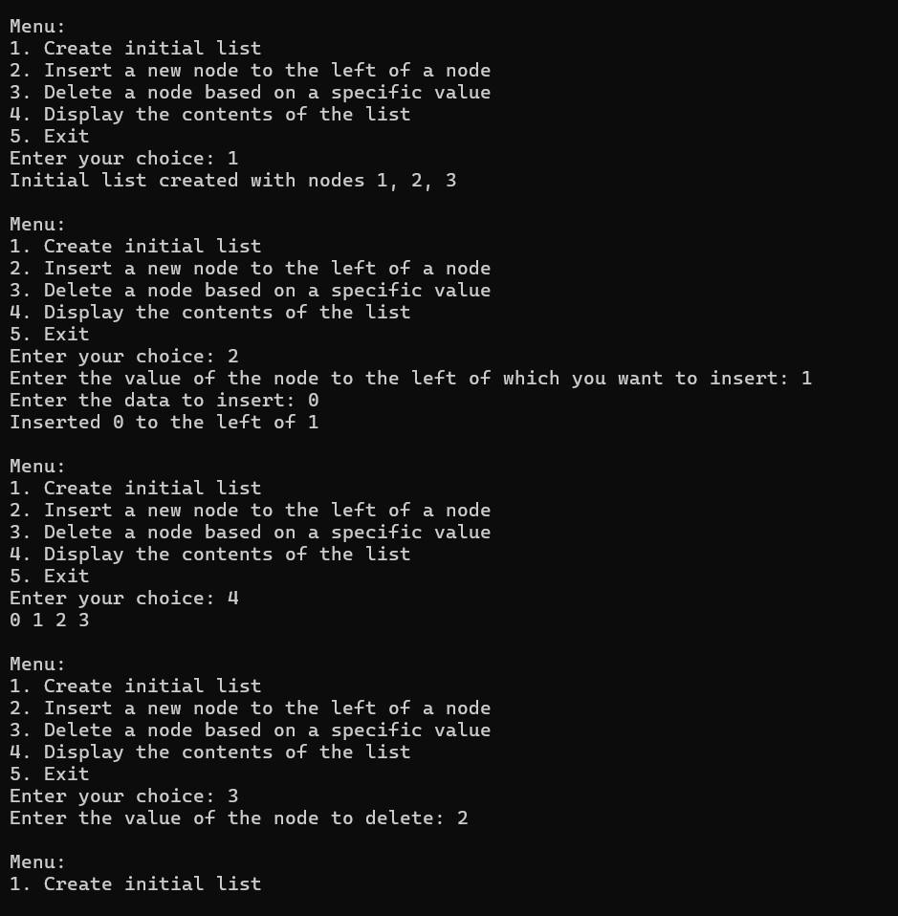

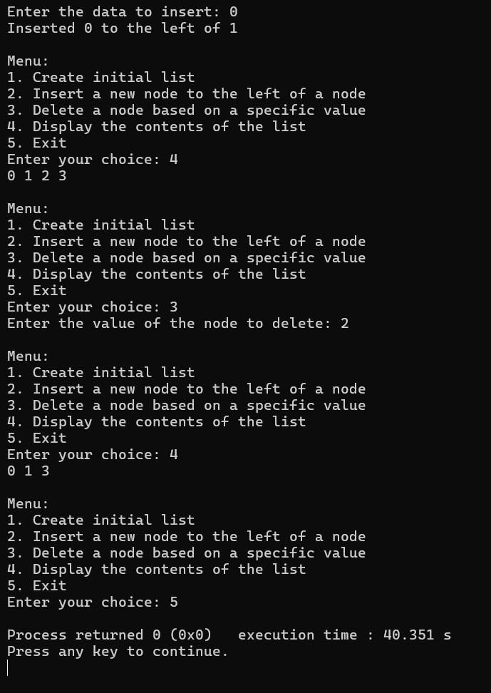

|  |  |
| --- | --- |
| **Lab program 7b:**  **Program - Leetcode platform**  **bool hasCycle(struct ListNode *head) { if (head == NULL || head->next == NULL) { return false;**  **}**  **struct ListNode *slow = head; struct ListNode *fast = head;**  **while (fast != NULL && fast->next != NULL) {**  **slow = slow->next; fast = fast->next->next; if (slow == fast) {**  **return true;**  **}**  **}**  **return false;**  **}**  **struct ListNode* createNode(int val) { struct ListNode* newNode = (struct ListNode*)malloc(sizeof(struct ListNode)); newNode->val = val; newNode->next = NULL; return newNode;**  **}**  **struct ListNode* createLinkedListWithCycle(int arr[], int size, int pos) {**  **if (size == 0) return NULL;**  **struct ListNode* head = createNode(arr[0]); struct ListNode* current = head;**  **struct ListNode* cycleNode = NULL;**  **for (int i = 1; i < size; i++) { current->next = createNode(arr[i]); current = current->next; if (i == pos) {**  **cycleNode = current;**  **}**  **}**  **if (cycleNode != NULL) { current->next = cycleNode;**  **} return head;**  **}** | 36 |

**Output:**

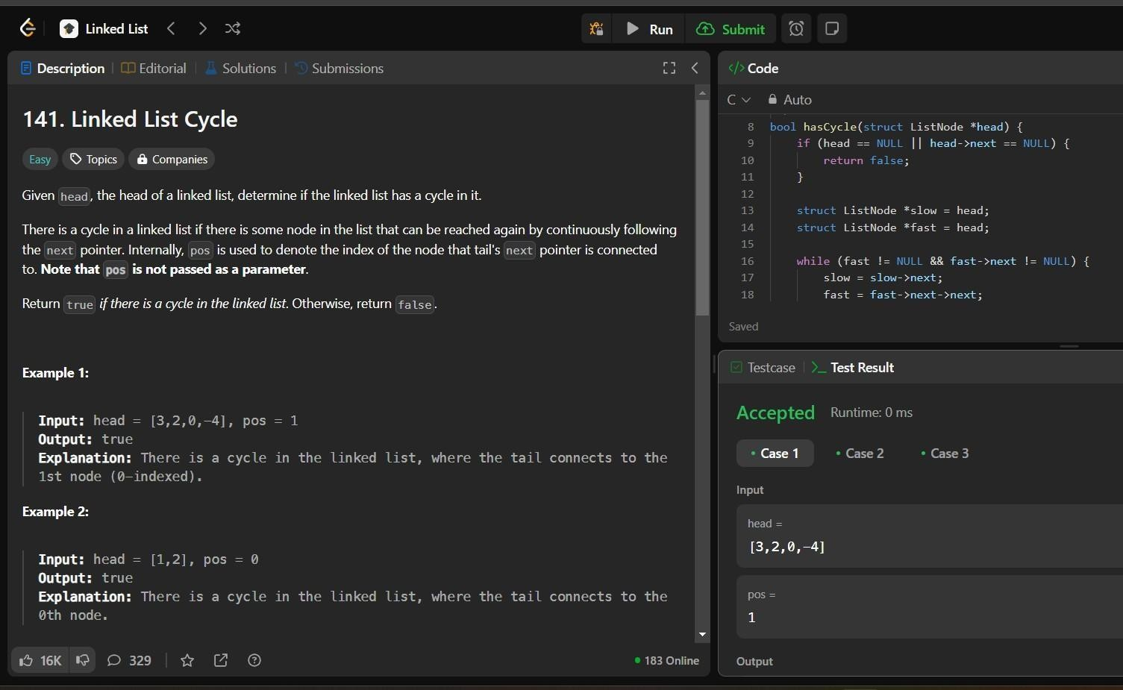

**Lab program 8a:**

**Write a program**

1. **ToconstructabinarySearchtree.**
2. **To traverse the tree using all the methods i.e., in-order, preorder and post order**
3. **To display the elements in the tree.**

**#include<stdio.h>**

**#include<stdlib.h>**

**struct Node{ int data; struct Node *left,*right;**

**};**

**struct Node *createNode(int data){**

**struct Node *newnode=(struct Node*)malloc(sizeof(struct Node)); newnode->data=data;**

**newnode->left=newnode->right=NULL; return newnode;**

**};**

**struct Node*insert(struct Node *root,int data){**

**if(root==NULL){**

**return createNode(data);**

**}**

**if(data<root-data){**

|  |  |
| --- | --- |
| **root->left=insert(root->left,data);**  **}**  **else if(data>root->data){ root->right=insert(root->right,data);**  **}**  **return root;**  **};**  **void inOrder(struct Node*root){ if(root!=NULL){ inOrder(root->left); printf("%d ",root->data);**  **inOrder(root->right);**  **}**  **}**  **void preOrder(struct Node *root){ if(root!=NULL){ printf("%d ",root->data); preOrder(root->left);**  **preOrder(root->right);**  **}**  **}**  **void postOrder(struct Node *root){ if(root!=NULL){ postOrder(root->left); postOrder(root->right);**  **printf("%d ",root->data);**  **}**  **}**    **void main(){ struct Node *root=NULL;**  **int choice,data; while(1){ printf("1.Insert into BST \n2.In-Order Traversal \n3.Pre-Order Traversal \n4.Post-order**  **Traversal \n5.exit\n"); printf("Enter your choice: "); scanf("%d",&choice);**  **switch(choice){**    **case 1:printf("Enter the value to insert:"); scanf("%d",&data); root=insert(root,data); break;**  **case 2:printf("In-Order Traversal: "); inOrder(root);** | 38 |

**printf("\n"); break;**

**case 3:printf("Pre-Order Traversal: ");**

**preOrder(root); printf("\n"); break;**

**case 4:printf("Post-Order Traversal: ");**

**postOrder(root); printf("\n"); break;**

**case 5:exit(0);**

**break;**

**default:printf("Invalid choice...\n");**

**}**

**}**

**}**

**Output:**

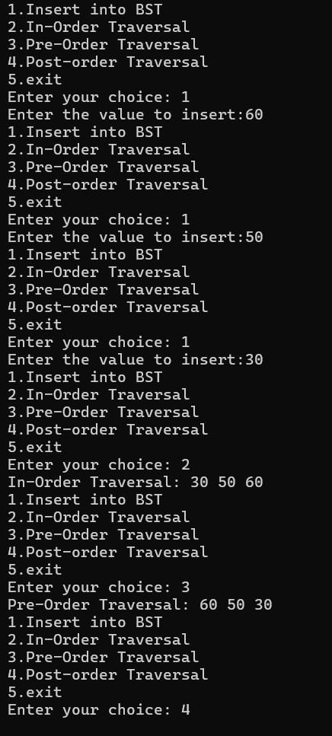

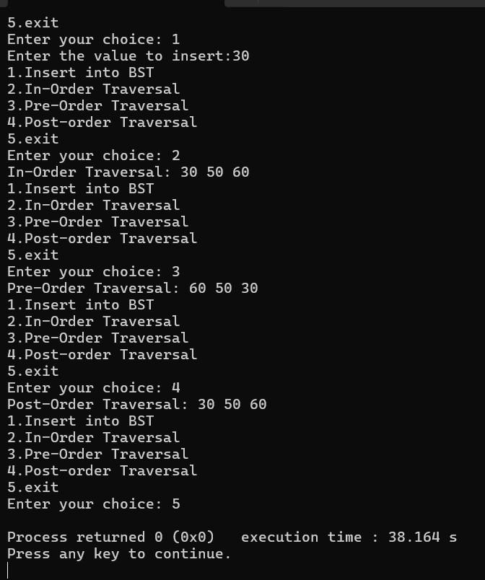

40

**Lab program 9:**

**9a. Write a program to traverse a graph using BFS method.**

**#include <stdio.h>**

**#define MAX 100**

**int graph[MAX][MAX], visited[MAX], queue[MAX]; int front = 0, rear = 0;**

**// BFS Function void BFS(int start, int n) { printf("BFS Traversal: "); visited[start] = 1; queue[rear++] = start;**

**while (front < rear) { int current = queue[front++]; printf("%d ", current);**

**for (int i = 0; i < n; i++) { if (graph[current][i] == 1 && !visited[i]) { visited[i] = 1; queue[rear++] = i;**

**}**

**}**

**}**

**printf("\n");**

**}**

**int main() { int n, start;**

**printf("Enter number of vertices: "); scanf("%d", &n);**

**printf("Enter adjacency matrix:\n"); for (int i = 0; i < n; i++) { for (int j = 0; j < n; j++) { scanf("%d", &graph[i][j]);**

**}**

**}**

**printf("Enter starting vertex: "); scanf("%d", &start);**

**BFS(start, n);**

**return 0;**

**}**

**Output:**

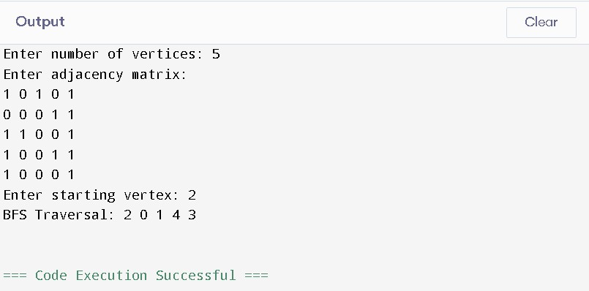

**9b. Write a program to check whether given graph is connected or not using DFS method.**

**#include <stdio.h>**

**#define MAX 100**

**int graph[MAX][MAX], visited[MAX];**

**// DFS Function void DFS(int start, int n) {**

**printf("%d ", start); // Print the current vertex**

**visited[start] = 1; // Mark the current vertex as visited**

**for (int i = 0; i < n; i++) {**

**if (graph[start][i] == 1 && !visited[i]) {**

**DFS(i, n); // Recursively visit connected vertices**

**}**

**}**

**}**

**// Check Connectivity int isConnected(int n) { // Reset visited array to 0 for (int i = 0; i < n; i++) {**

**visited[i] = 0;**

**}**

**// Perform DFS starting from vertex 0**

**DFS(0, n);**

**// Check if all vertices were visited**

**for (int i = 0; i < n; i++) { if (!visited[i]) {**

**return 0; // If any vertex is not visited, the graph is not connected**

**}**

**}**

**return 1; // All vertices are visited, graph is connected**

**}**

**int main() { int n;**

**printf("Enter the number of vertices: "); scanf("%d", &n);**

**printf("Enter the adjacency matrix:\n"); for (int i = 0; i < n; i++) { for (int j = 0; j < n; j++) {**

**scanf("%d", &graph[i][j]);**

**}**

**}**

**// Reset visited array before traversal**

**for (int i = 0; i < n; i++) {**

**visited[i] = 0;**

**}**

**printf("DFS Traversal: ");**

**DFS(0, n); // Perform DFS traversal from vertex 0 printf("\n");**

**if (isConnected(n)) {**

**printf("The graph is connected.\n");**

**} else {**

**printf("The graph is not connected.\n");**

**}**

**return 0;**

**}**

**Ou**

**tput**

**:**

**Lab program 10:**

**Given a File of N employee records with a set K of Keys(4**

**-**

**digit) which uniquely determine the**

**records in file F. Assume that file F is maintained in memory by a Hash Table (HT) of m memory**

**locations with L as the set of memory addresses (2**

**-**

**digit) of locations in HT. Let the keys in K and**

**addresses in L are integers. Design and develop a Program in C that uses Hash function H: K**

**-**

**L**

**>**

**as H(K)=K mod m (remainder method), and implement hashing technique to map a given key K to**

**the address space L. Resolve the collision (if any) using linear probing.**

**#include <stdio.h>**

**#include <stdlib.h>**

**#define MAX_EMPLOYEES 100 // Maximum number of employees**

**#define MAX_KEYS 100 // Maximum number of keys**

**#define TABLE_SIZE 10 // Size of hash table (m)**

**typedef struct {**

**int key;**

**// You can add other employee details here**

**// For simplicity, we use just the key**

**}**

**Employee;**

**int hashTable[TABLE_SIZE]; // Hash table to store keys**

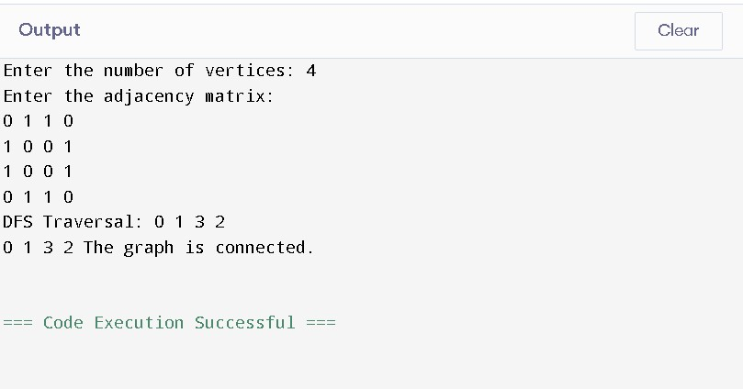

**Employee employees[MAX_EMPLOYEES]; // Array to store employee records int N; // Number of employees**

**int m = TABLE_SIZE; // Size of the hash table**

**// Hash function: H(K) = K mod m int hashFunction(int key) {**

**return key % m;**

**}**

**// Linear Probing to resolve collisions int linearProbing(int key) { int index = hashFunction(key);**

**int originalIndex = index; // Store original index to detect full table**

**while (hashTable[index] != -1) { if (hashTable[index] == key) {**

**return index; // Key already exists (no insertion needed)**

**}**

**// Linear probing: move to the next index**

**index = (index + 1) % m;**

**// If we have checked all positions, return -1 indicating table is full if (index == originalIndex) {**

**return -1;**

**}**

**}**

**return index;**

**}**

**// Function to insert a key into the hash table void insert(int key) {**

**int index = linearProbing(key);**

**if (index != -1) {**

**hashTable[index] = key; // Store the key at the found index**

**printf("Key %d inserted at index %d\n", key, index);**

**} else {**

**printf("Error: Hash table is full. Key %d cannot be inserted.\n", key);**

**}**

**}**

**// Function to display the hash table void displayHashTable() { printf("\nHash Table:\n"); for (int i = 0; i < m; i++) { if (hashTable[i] != -1) {**

**printf("Index %d: Key %d\n", i, hashTable[i]);**

**} else {**

**printf("Index %d: Empty\n", i);**

**}**

**}**

**}**

**int main() {**

**// Initialize hash table to -1 (empty)**

**for (int i = 0; i < m; i++) {**

**hashTable[i] = -1;**

**}**

**printf("Enter number of employees: "); scanf("%d", &N);**

**printf("Enter the employee keys (4-digit numbers):\n"); for (int i = 0; i < N; i++) {**

**scanf("%d", &employees[i].key); // Read key for each employee**

**}**

**// Insert the employee keys into the hash table for (int i = 0; i < N; i++) {**

**insert(employees[i].key);**

**}**

**// Display the final hash table**

**displayHashTable();**

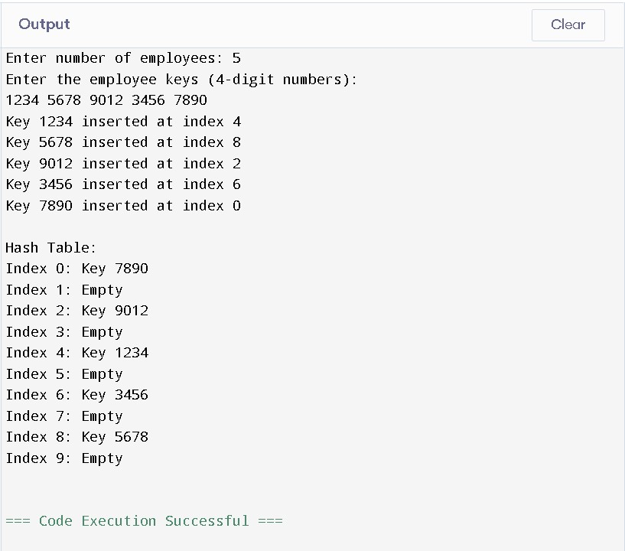 **return 0;**

**}**

**Output:**